### K-Means Algorithm

**Program:**

**import numpy as np**

**import matplotlib.pyplot as plt**

**from sklearn.cluster import KMeans**

**from sklearn.mixture import GaussianMixture**

**# Generate synthetic data**

**np.random.seed(42)**

**X1 = np.random.normal(loc=[2, 2], scale=0.5, size=(100, 2))**

**X2 = np.random.normal(loc=[8, 8], scale=0.5, size=(100, 2))**

**X3 = np.random.normal(loc=[2, 8], scale=0.5, size=(100, 2))**

**X = np.vstack((X1, X2, X3)) # Combine into one dataset**

**# Step 1: K-Means Initialization**

**k = 3 # Number of clusters**

**kmeans = KMeans(n_clusters=k, random_state=42)**

**kmeans.fit(X)**

**kmeans_labels = kmeans.labels_**

**# Step 2: Expectation-Maximization (Gaussian Mixture Model)**

**gmm = GaussianMixture(n_components=k, covariance_type='full', random_state=42)**

**gmm.fit(X)**

**gmm_labels = gmm.predict(X)**

**# Plot Results**

**fig, axes = plt.subplots(1, 2, figsize=(12, 5))**

**# Plot K-Means Clustering**

**axes[0].scatter(X[:, 0], X[:, 1], c=kmeans_labels, cmap='viridis', marker='o')**

**axes[0].scatter(kmeans.cluster_centers_[:, 0], kmeans.cluster_centers_[:, 1], c='red', marker='x', s=100, label='Centroids')**

**axes[0].set_title("K-Means Clustering")**

**axes[0].legend()**

**# Plot GMM Clustering**

**axes[1].scatter(X[:, 0], X[:, 1], c=gmm_labels, cmap='viridis', marker='o')**

**axes[1].set_title("EM Algorithm (Gaussian Mixture Model)")**

**plt.show()**

**Output:**

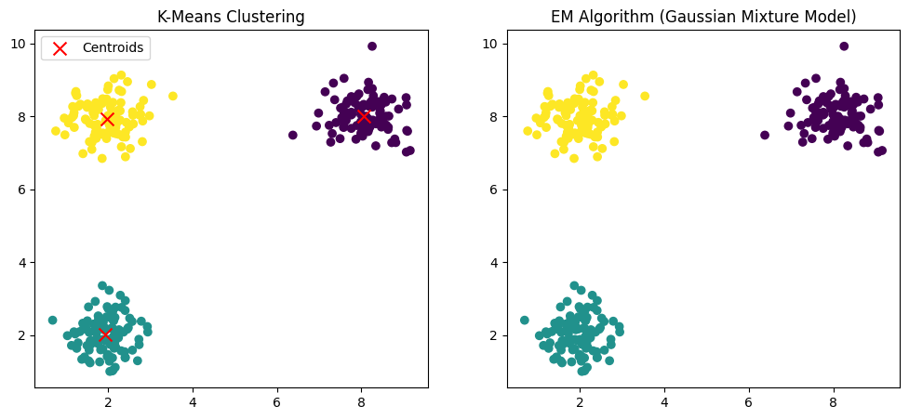

# KNN On the Iris Dataset

**Program:**

**import numpy as np**

**import matplotlib.pyplot as plt**

**from sklearn import datasets**

**from sklearn.model_selection import train_test_split**

**from sklearn.preprocessing import StandardScaler**

**from sklearn.neighbors import KNeighborsClassifier**

**from sklearn.metrics import accuracy_score, classification_report, confusion_matrix**

**# Load the Iris dataset**

**iris = datasets.load_iris()**

**X = iris.data # Features: Sepal length, Sepal width, Petal length, Petal width**

**y = iris.target # Class labels: 0 (Setosa), 1 (Versicolor), 2 (Virginica)**

**# Split dataset into training and testing sets (80% training, 20% testing)**

**X_train, X_test, y_train, y_test = train_test_split(X, y, test_size=0.2, random_state=42)**

**# Normalize the data (optional but improves performance)**

**scaler = StandardScaler()**

**X_train = scaler.fit_transform(X_train)**

**X_test = scaler.transform(X_test)**

**# Choose the number of neighbors (K)**

**k = 5**

**# Train the KNN classifier**

**knn = KNeighborsClassifier(n_neighbors=k)**

**knn.fit(X_train, y_train)**

**# Make predictions**

**y_pred = knn.predict(X_test)**

**# Evaluate the model**

**accuracy = accuracy_score(y_test, y_pred)**

**print(f"Accuracy: {accuracy * 100:.2f}%")**

**print("\nClassification Report:\n", classification_report(y_test, y_pred))**

**# Confusion Matrix**

**conf_matrix = confusion_matrix(y_test, y_pred)**

**print("\nConfusion Matrix:\n", conf_matrix)**

**# Visualize predictions (only for 2D projections)**

**plt.figure(figsize=(8, 6))**

**plt.scatter(X_test[:, 0], X_test[:, 1], c=y_pred, cmap='viridis', edgecolors='k', marker='o', s=100)**

**plt.title(f'KNN Classification (K={k}) on Iris Dataset')**

**plt.xlabel('Feature 1 (Sepal Length)')**

**plt.ylabel('Feature 2 (Sepal Width)')**

**plt.colorbar(label="Predicted Class")**

**plt.show()**

**OUTPUT:**

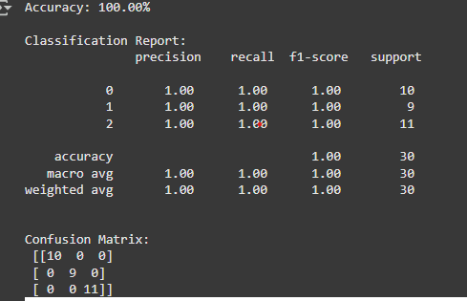

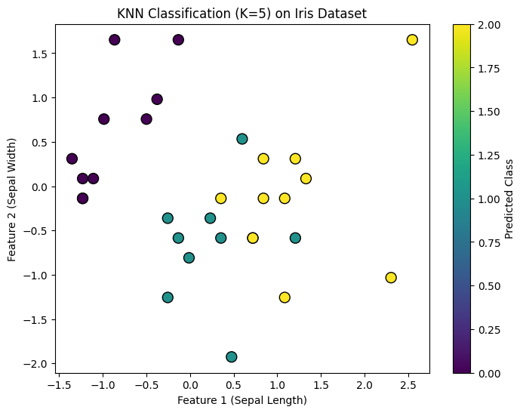

**Required Dependencies:**

**pip install numpy matplotlib scikit-learn**